Resource Manager

The entire UI for resource Manager needs to be same as Vendor section like font, colour etc
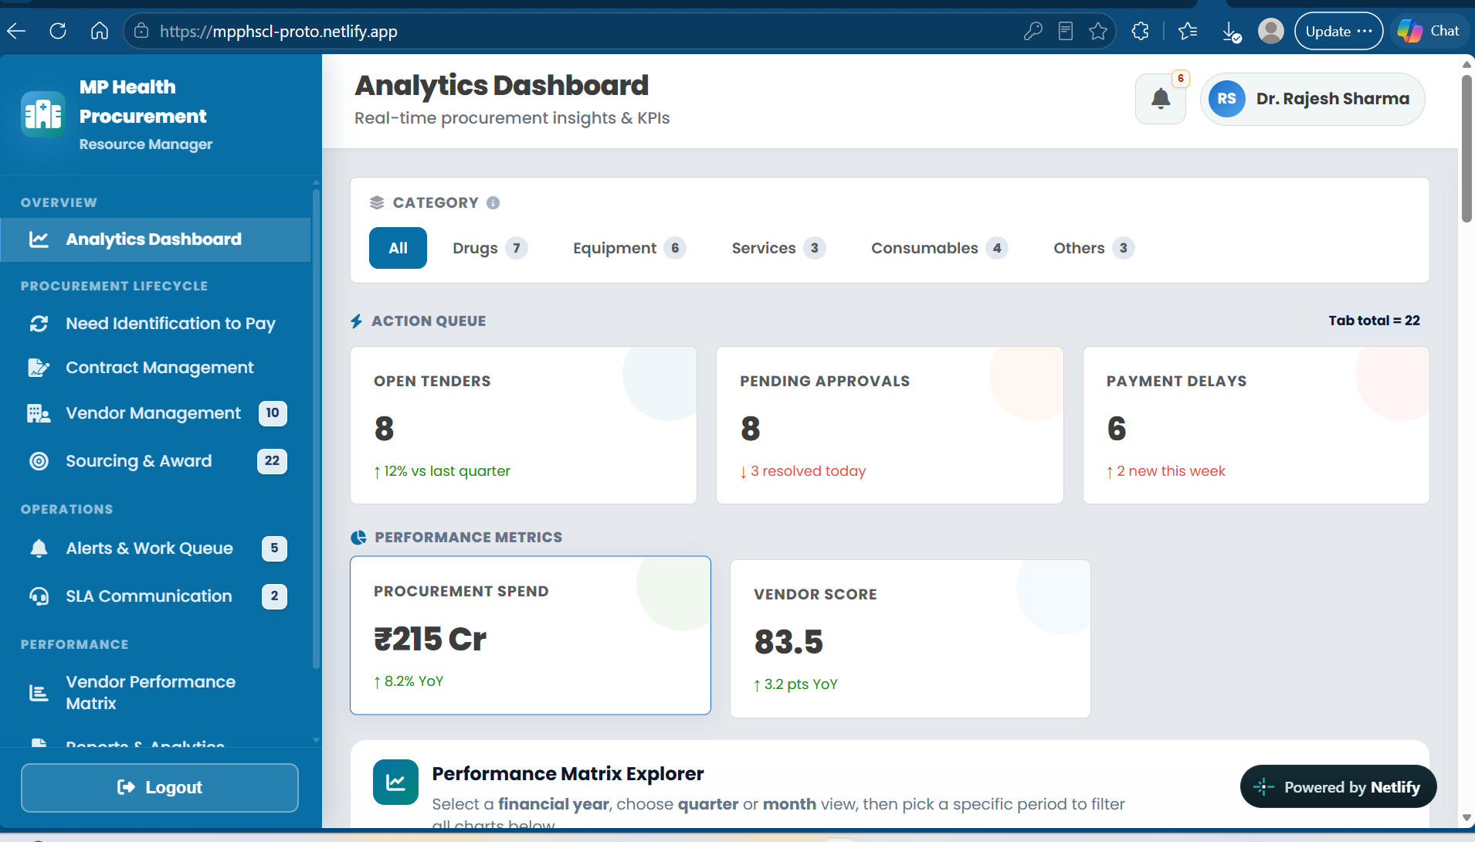

Fix the UI and if user will click on Drug, Equipment and Consumables, the details are coming as per item wise as you did earlier
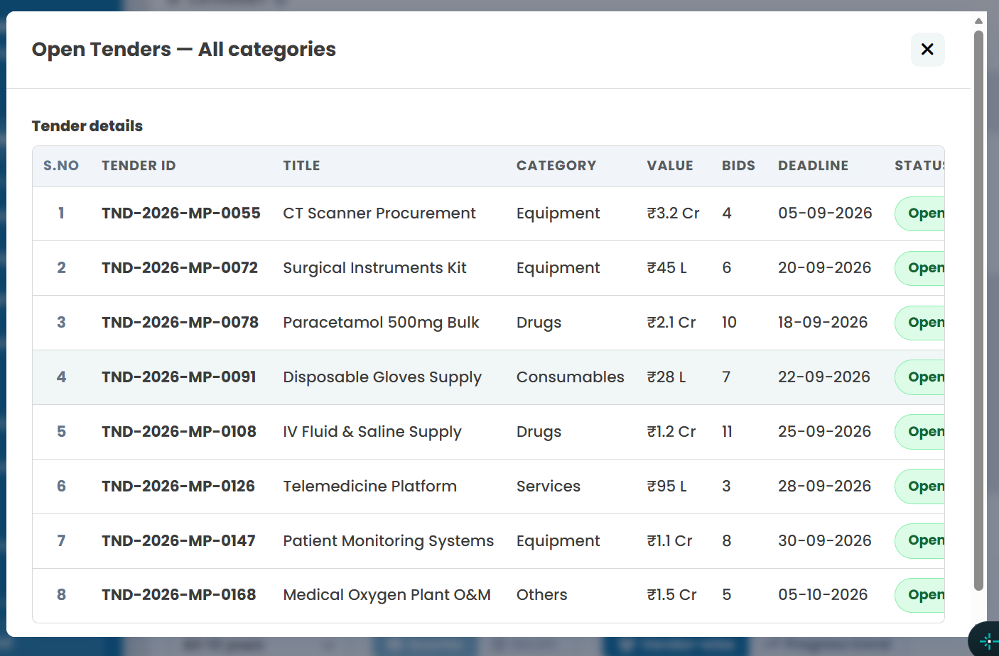

Need to be removed in “Indent Raised” Step

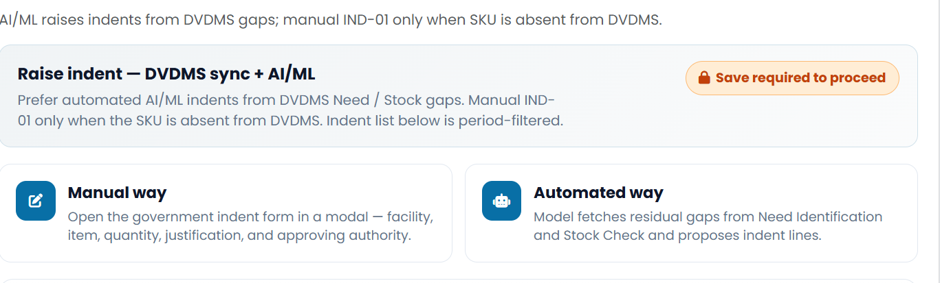

Always shows “From eProc Portal” in the “Source” column and please add Category filter above Table

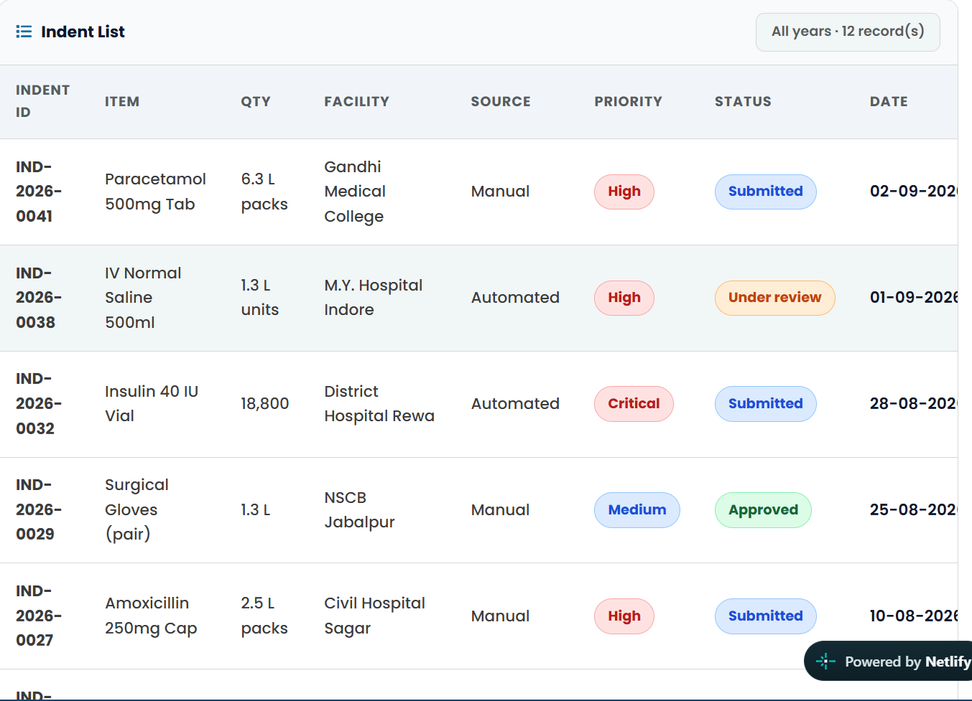

Without raising Indent, user will go to next step as there is no provision for Raise Indent

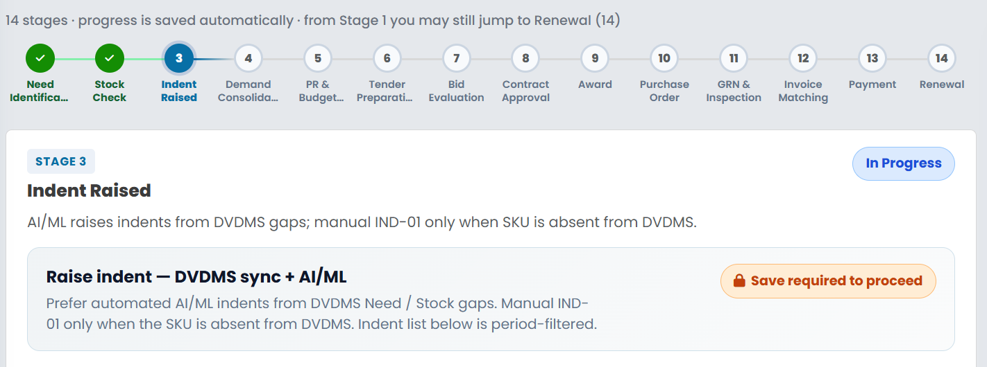

In step “Demand Consolidation”, Category filter is missing and use Demand List instead of “Demand Approval List”. If Demand will be rejected or not approved, then will show the reason also in details modal pop up

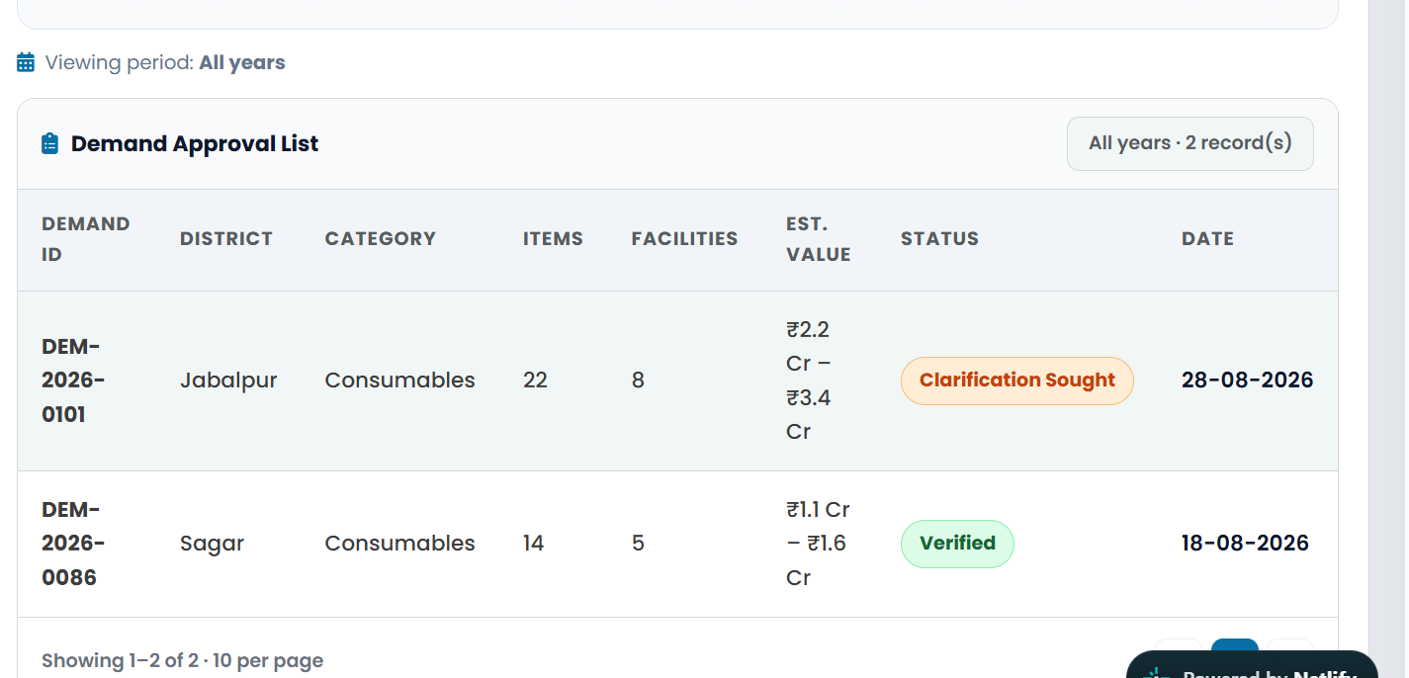

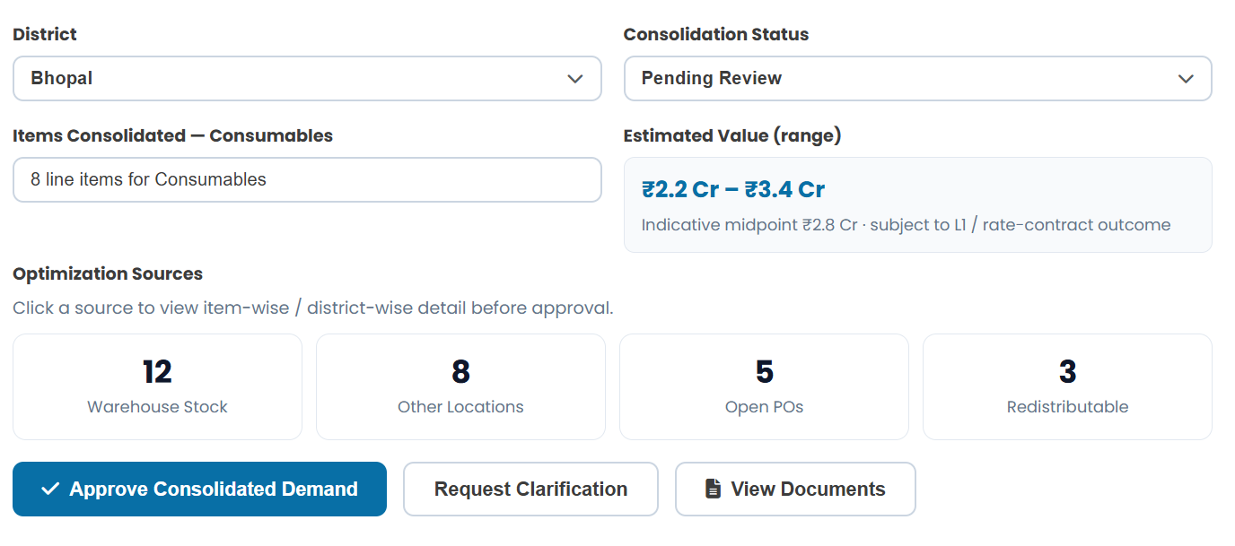

This section need to be removed

Category filter is missing here in step “PR & Budget Approval”

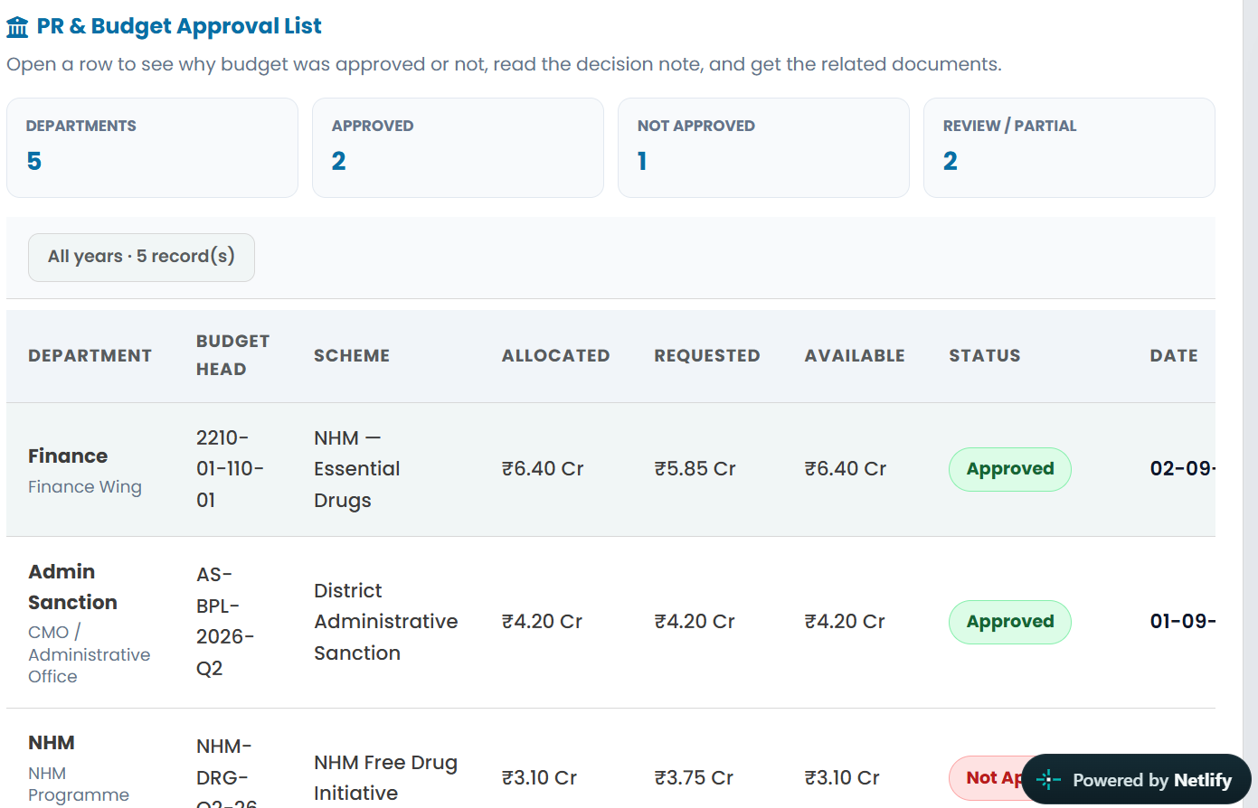

In “PR & Budget Approval” step, the below details are removed

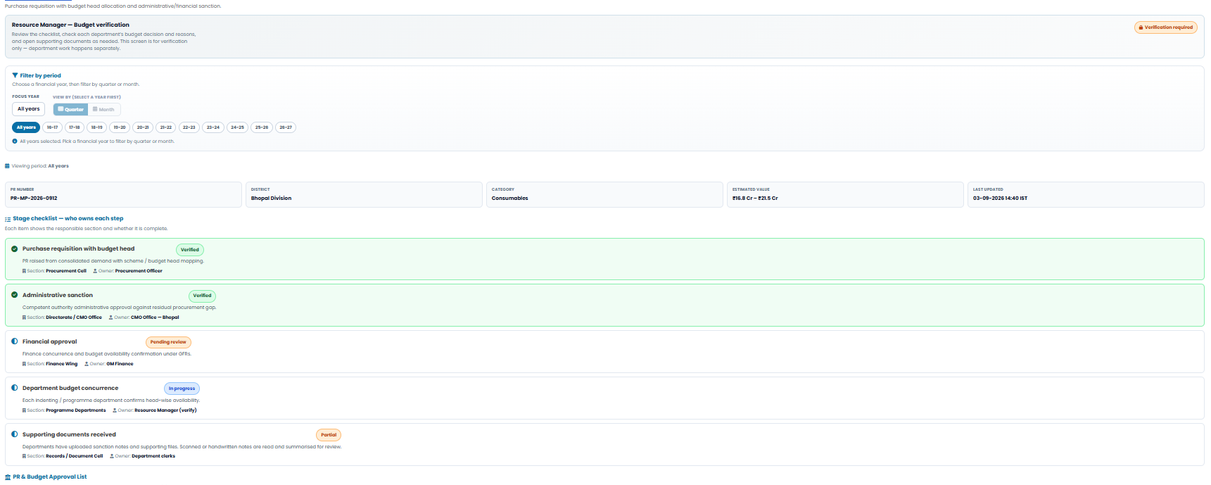

In “Tender Preparation” step, the page is redesign like the below way
- Purpose of the Tender
- Uploaded all the related documents that helps to build the initial RFP/Notice Inviting Tender(NIT)
- Able to download the Final RFP and make a consent from the different departments
- If any suggestions come from any department, then provision to upload those details based on the RFP and do the changes accordingly by the help of Ai/ML and OCR and also upload the consent from different stakeholders inside Government
- Prepare the Final Tender
- Download options
Now, based on the downloadable documents from NIC portal, showcase all the tender details that are active and click on any tender, the details will be shown on a pop up and maintain the same logic for Drugs, Equipment and Consumables (Item wise) and all the exiting filters like category wise, year/quarter/month wise etc

In “Bid Evaluation” step, all the details of the bid, like Item wise for Drugs, Consumables, Equipment and category wise Service, Other with L1 details and all the existing filtration like Category wise and year/Month/Quarter wise. Click on each row to get the details along with l1, l2, l3 etc details to compare

In “Contract Approval”, share a table for all the contract approval list with all the existing filtration like Category wise, Year/Quarter/ Month wise. Create a form and all the relevant details are either fetch from DVDMS by API integration or fetch manually by the uploaded documents
Table like this
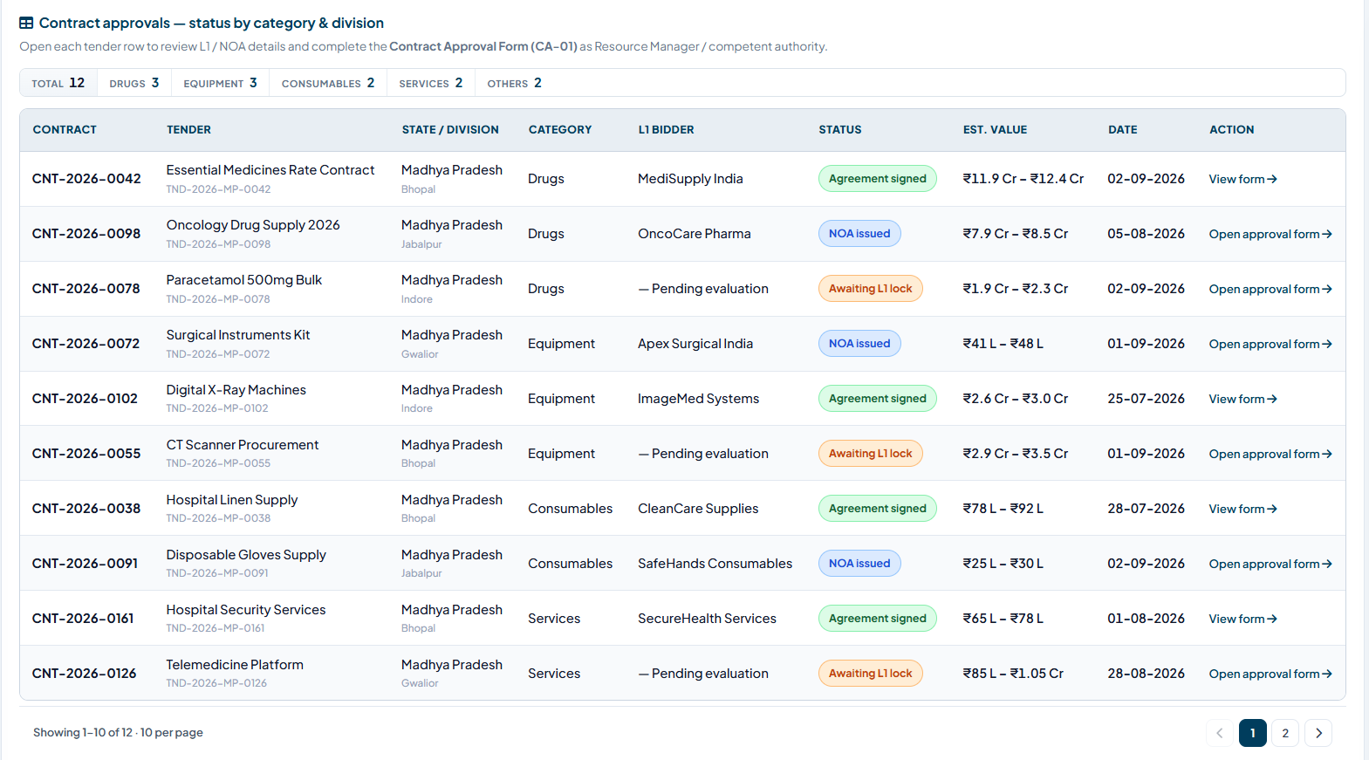

In “Award”, generate Award based on the documents we have or API integration with DVDMS and share a tabular list with all the existing filtration like Category wise, Year/Quarter/ Month wise for all the bidders

In “Purchase Order”, generate purchase order based on the documents we have or API integration with DVDMS and share a tabular list with all the existing filtration like Category wise, Year/Quarter/ Month wise for all the bidders

In “GRN & Inspection”, checking GRN based on the documents we have or API integration with DVDMS and share a tabular list with all the existing filtration like Category wise, Year/Quarter/ Month wise for all the bidders and also take follow up if Bidder upload wrong GRN

In “Invoice matching”, checking Invoice based on the documents we have or API integration with DVDMS for a particular tender and share a tabular list with all the existing filtration like Category wise, Year/Quarter/ Month wise for all the bidders and also take follow up if Bidder upload wrong Invoice

In “Payment”, checking Payment based on the documents we have or API integration with DVDMS for a particular tender and share a tabular list with all the existing filtration like Category wise, Year/Quarter/ Month wise for all the bidders and also take follow up if Payment value has some discrepancy

In “Contract Management”, checking Contract Management based on the documents we have or API integration with DVDMS for a particular tender and share a tabular list with all the existing filtration like Category wise, Year/Quarter/ Month wise for all the bidders

In “Vendor Management”, remove all the NIC, DVDMS or any portal name here. Also share the below details only
- Based on Vendor Performance matrix the data should be displayed from top to bottom
- Categorise based on the self-registration or fetch from the DVDMS portal
- Use all the filtration like Category wise, Year/Quarter/ Month wise
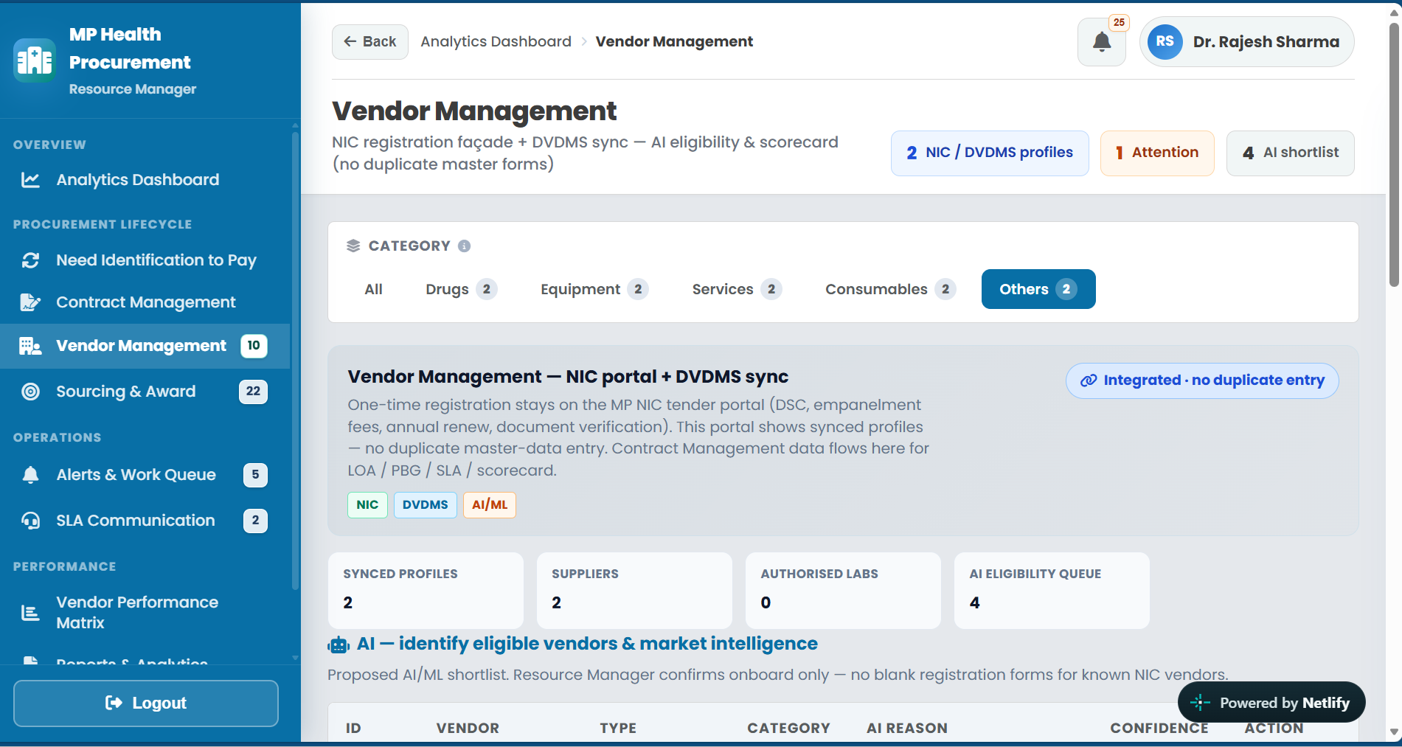

Remove from the “Sourcing & Award”

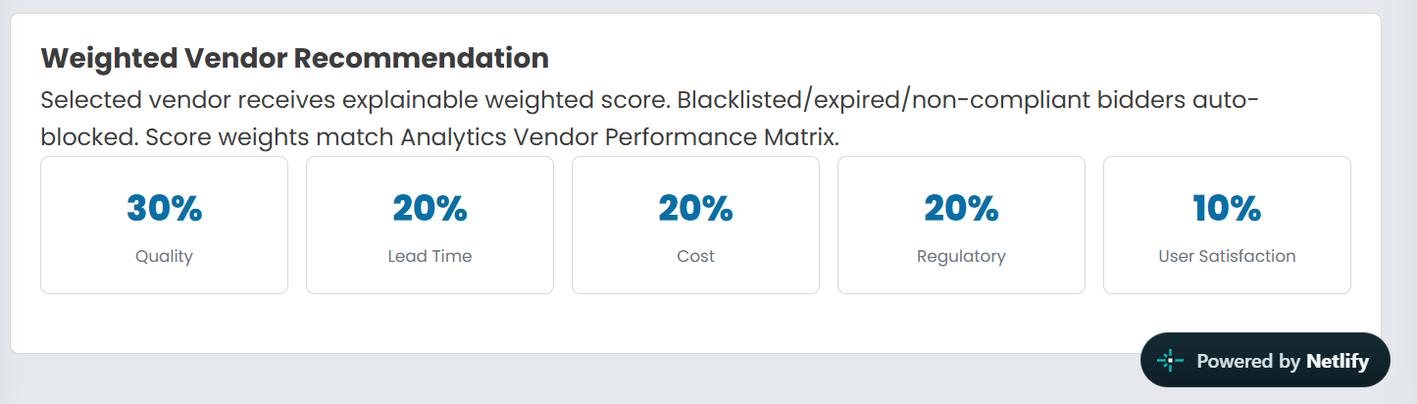

In “Sourcing & Award”, the sections for Open Tenders — Equipment (3), Pending Approvals — Equipment (2), Payment Delays — Equipment (1) – need all the filtration like Category wise, Year/Quarter/ Month wise

Create Vendor Performance matrix based on
- Quality Testing through Labs
- Communication response
- Timely Delivery
- Packaging & supply
- Pricing
- Blacklisting status
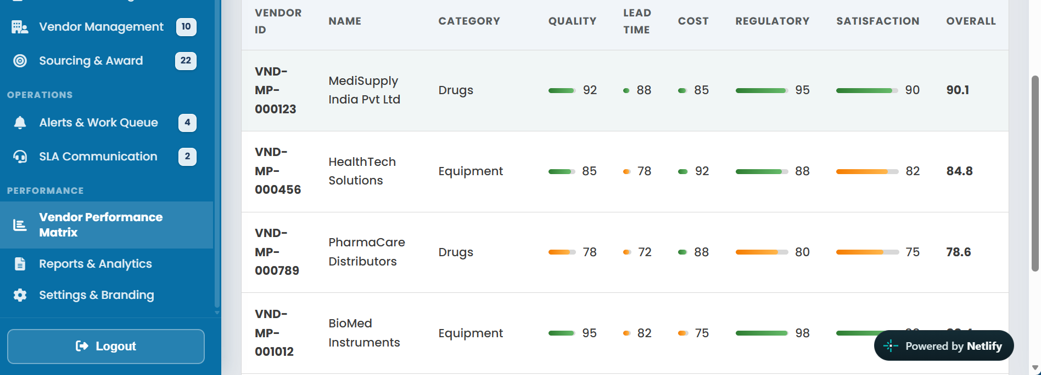

In “Reports & Analytics”, the excel and pdf should be in a respective section and download options should work
